Problem Statements & Queries

1. Insert a New Movie into the Database
Problem: A new blockbuster movie needs to be added to the database.

db.movies.insertOne({
title: "Avatar 3",
year: 2025,
genre: ["Sci-Fi", "Adventure"],
director: "James Cameron",
rating: 9.1,
boxOffice: 1500000000
});

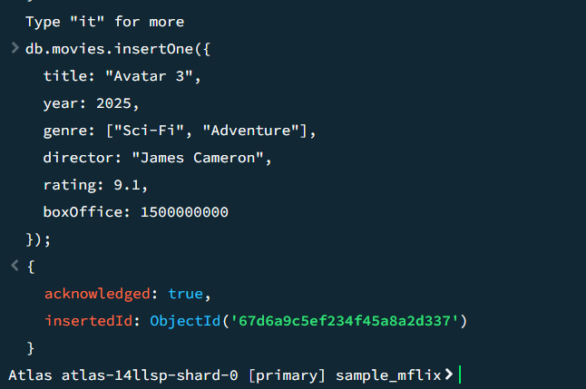

2. Bulk Insert Multiple Movies
Problem: Insert multiple movies at once.
db.movies.insertMany([
{ title: "Interstellar", year: 2014, genre: ["Sci-Fi"], rating: 8.6 },
{ title: "Inception", year: 2010, genre: ["Sci-Fi", "Thriller"], rating: 8.8 },
{ title: "The Dark Knight", year: 2008, genre: ["Action", "Drama"], rating: 9.0 }
]);

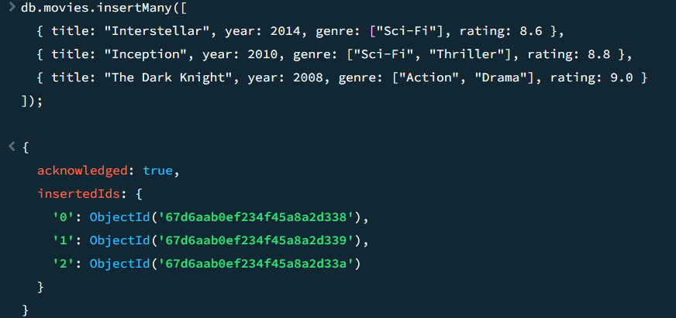

3. Find Movies Belonging to ‘Sci-Fi’ or ‘Action’ Genre
Problem: Filter movies based on genre.

db.movies.find({ genre: { $in: ["Sci-Fi", "Action"] } });

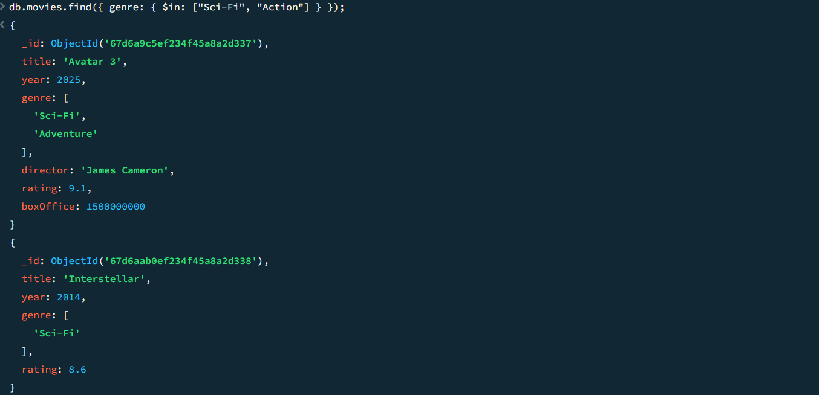

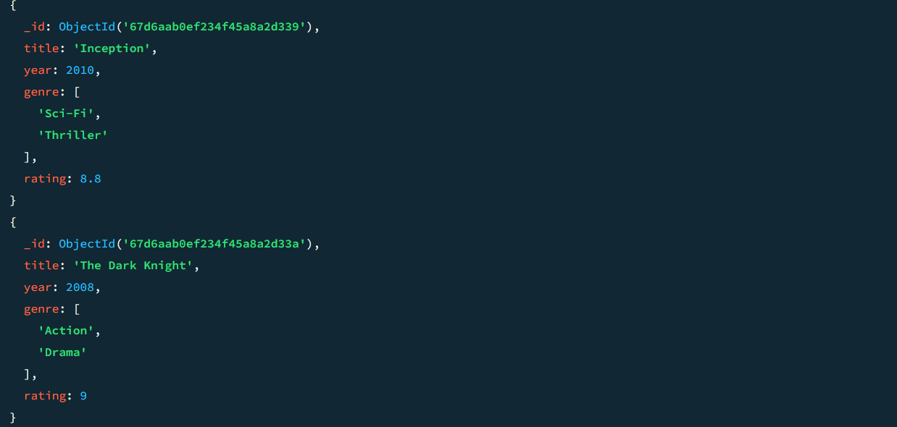

4. Increase the Box Office Collection for a Movie
Problem: A movie's earnings increased.

db.movies.updateOne({ title: "Avatar 3" }, { $inc: { boxOffice: 500000000 } });

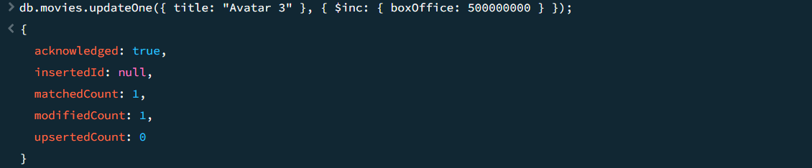

5. Add a New Genre to an Existing Movie
Problem: "Inception" should also be labeled as "Mind-Bending".

db.movies.updateOne({ title: "Inception" }, { $push: { genre: "Mind-Bending" } });

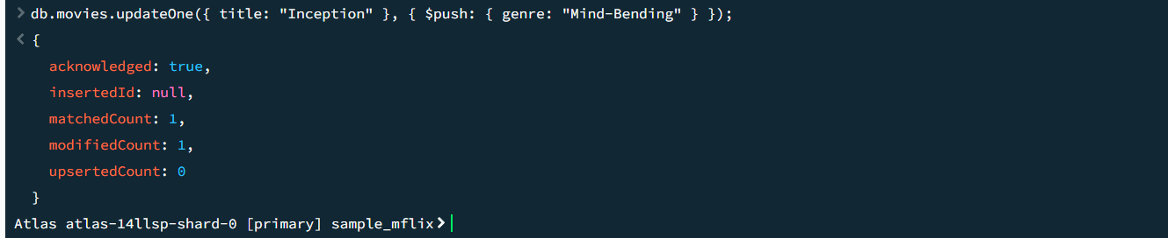

6. Remove a Specific Genre from a Movie
Problem: Remove "Drama" from "The Dark Knight".

db.movies.updateOne({ title: "The Dark Knight" }, { $pull: { genre: "Drama" } });

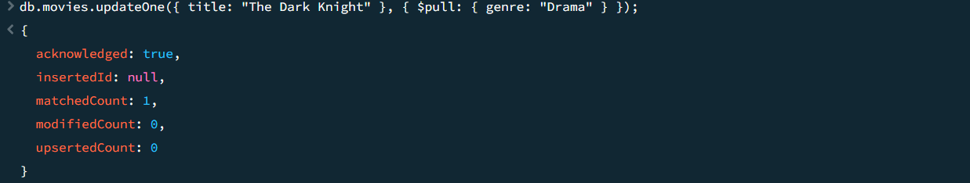

7. Aggregate: Count Movies per Genre
Problem: Get a genre-wise count of movies.

db.movies.aggregate([
{ $unwind: "$genre" },
{ $group: { _id: "$genre", count: { $sum: 1 } } }
]);

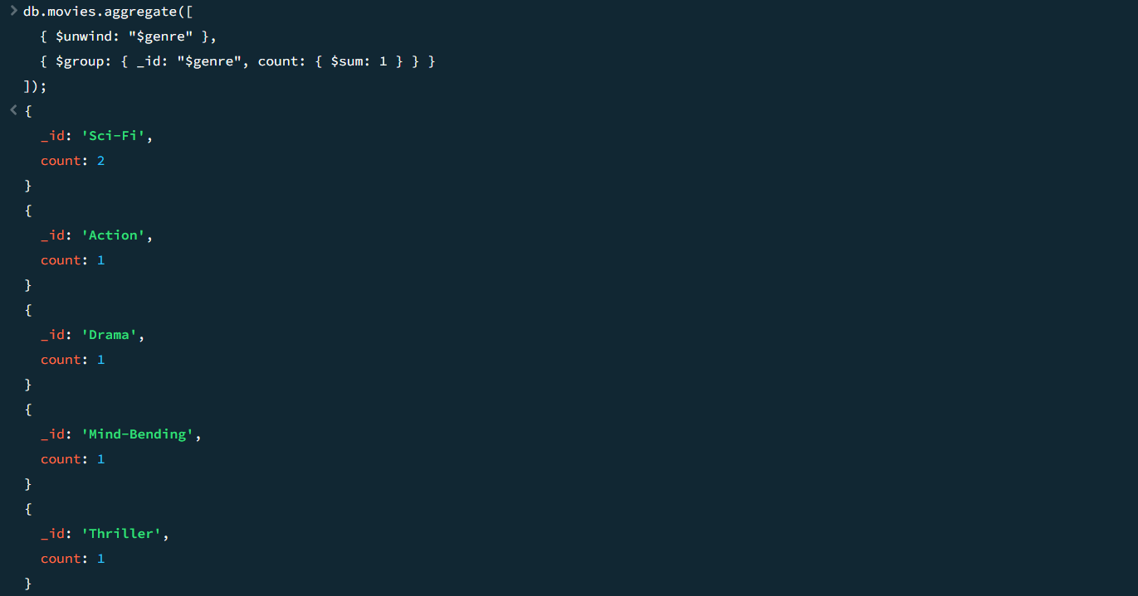

8. Find the Top 3 Highest-Rated Sci-Fi Movies
Small Output: Limited to 3 results.
db.movies.find({ genre: "Sci-Fi" })
.sort({ rating: -1 })
.limit(3);
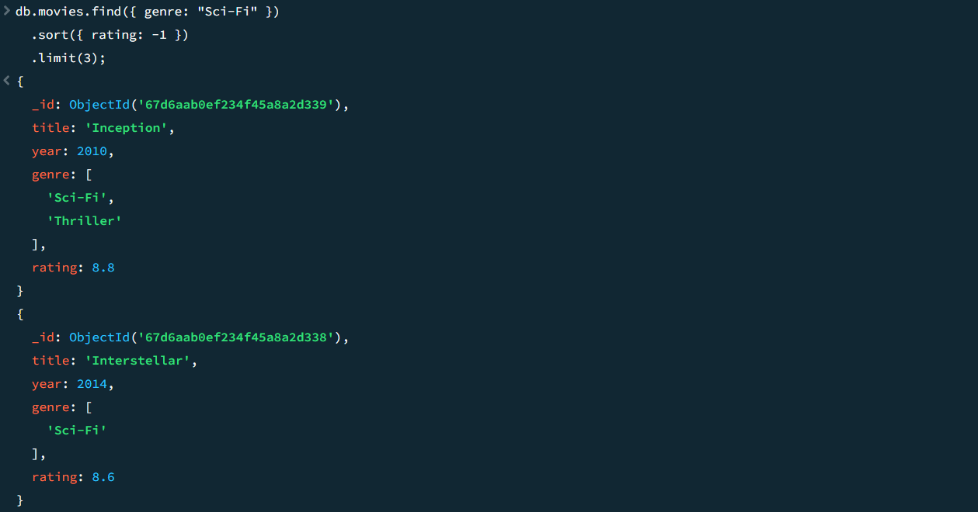

9. Find the Most Common Genre in the Database
Small Output: Only the most frequent genre.
db.movies.aggregate([
{ $unwind: "$genre" },
{ $group: { _id: "$genre", count: { $sum: 1 } } },
{ $sort: { count: -1 } },
{ $limit: 1 }
]);

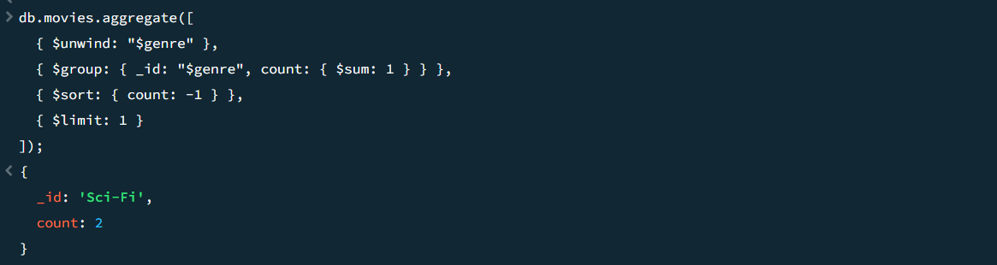

10. Find the Oldest Movie in the Database
Small Output: Only 1 result.
db.movies.find().sort({ year: 1 }).limit(1);

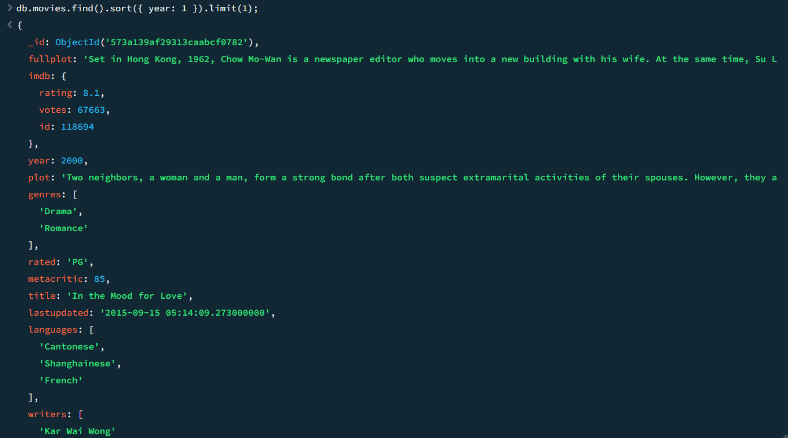

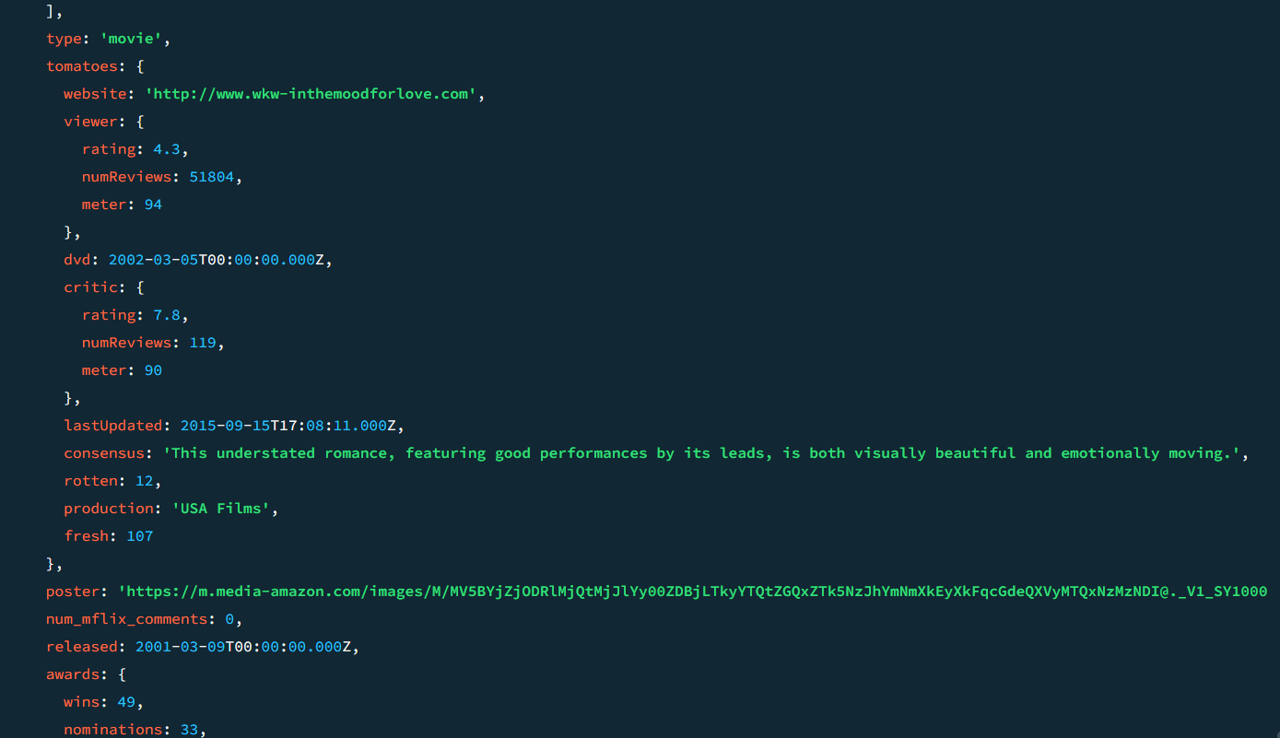



11. Find the Highest-Rated Movie of Each Genre
Small Output: One movie per genre.

db.movies.aggregate([
{ $unwind: "$genre" },
{ $sort: { genre: 1, rating: -1 } },
{ $group: { _id: "$genre", topMovie: { $first: "$title" } } }
]);



